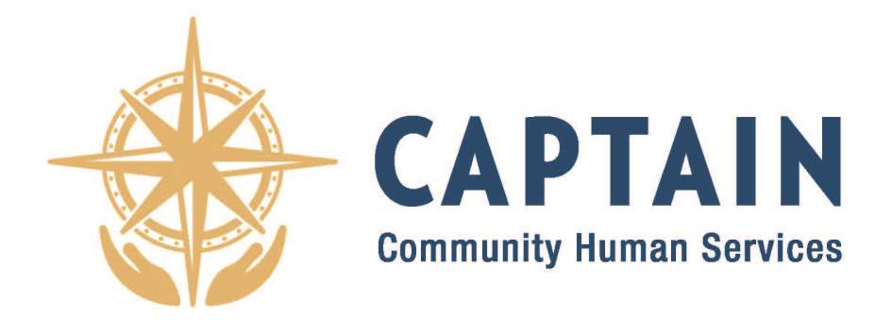

Job Title: School Based Youth Peer Advocate/CRPA (Full Time, Non-Exempt)

Pay Rate: $23.08 per hour

Location: Burnt Hills Ballston Lake School District/Shenendehowa School District

Job Category: Case Manager
Provide individuals and families with case management and support to cope with physical, medical, social, financial, and psychosocial needs. Responsible for screening and interviewing potential clients, developing action plans and goals with client, connecting client with additional resources including training, education, healthcare, and financial, assisting client with problem solving, providing support and encouragement and monitoring client success.

Job Summary:
The School Based Youth Peer Recovery Advocate will provide peer support services including outreach, mentoring, and recovery support services to those seeking or sustaining recovery in a manner that is consistent with evidence-based best practices. Using a harm reduction and person-centered approach, combined with personal experience, they will learn about the needs of individuals encountered, provide education on services and resources available to them, and provide warm handoff introductions to service providers.

The CRPA will conduct outreach services, assist with community education and undertake targeted treatment engagement and treatment support activities specifically focused on individuals with substance use disorder in Saratoga County School Districts.

Duties and Responsibilities:
- Conduct outreach and engage individuals in School Districts within Saratoga County as assigned by Youth Development Program Manager.
- Employ engagement strategies to learn about the needs of individuals encountered and see how best to support them.
- Utilize harm reduction and person-centered approaches when meeting individuals.
- Hand out safer use kits and provide education on Narcan administration and fentanyl strips per school policies.
- Inform individuals encountered on the services and resources available to them in the community.
- Maintain a social service provider network to increase access to referral sources.
- Make referrals based on individual need, which may include medical, housing, mental health, and substance use.
- Provide timely response to youth referred for services.
- Assist families/individuals access transportation services to help provide warm handoff introductions to service providers.
- Complete documentation and reports as needed.
- Other job duties as assigned.

Telecommuting and Remote Work:
- Generally, work from home is not a viable option due to this position being on site in Saratoga County School Districts. Occasionally, work projects could be completed at home with supervisory permission.

Skills Required:
- Ability to work with all ages.
- Knowledge of community resources.
- Positive image for CAPTAIN and a dedicated youth advocate.
- Able to multi-task and work in a team environment.
- Ability to work with a diverse client base and staff in a professional manner as part of a team. Excellent organizational and interpersonal skills, flexibility and initiative.
- Good communication skills and proven ability to work with adolescents and children.

Qualifications:
- New York Certified Peer Recovery Advocate (provisional accepted)
- Must possess a valid and clean NYS Driver License, with Motor Vehicle Record acceptable to agency insurance
- Must be able to pass NYS Central Registry background check and school district fingerprinting
- Ability to lift to 30 lbs.

Employer Disclaimer:

- Employees will be required to follow any other job-related instructions and to perform any other job-related duties requested by their direct supervisor.
- This job description does not create an employment contract, implied or other than an “at will” employment relationship.

CAPTAIN CHS is proud to be an Equal Opportunity Employer (EOE).

*To apply please send Cover Letter and Resume to the following:

Kevin Guyette, Youth Development Program Manager, at Kevin@captaincares.org

